**EXPERIMENT 9:**

Create a simple cloud software application for Hospital information system for SIMATS Hospital using any Cloud Service Provider to demonstrate SaaS with fields of patient name, age, address, phone, email, Attender name, attender phone, doctor name, diseases, etc.

**AIM:**

To Create a simple cloud software application for Hospital information system using any Cloud Service Provider to demonstrate SaaS.

**PROCEDURE:**

**step1:** Go to zoho.com.

**step 2:** Log into the zoho.com.

**step 3:** Select one application step.

**step4:** Enter application name as Hospital information system.

**step 5:** Created new application as Hospital information system.

Step 6:create a new form for login details .

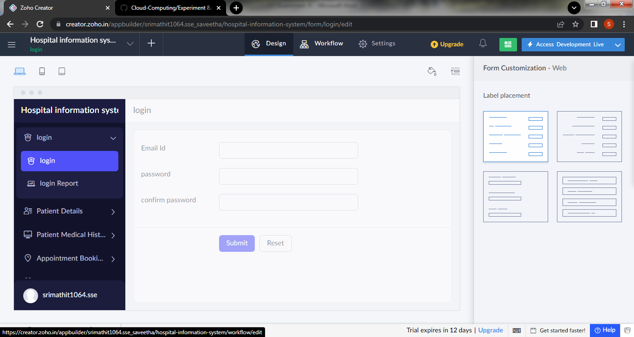

Step 7: create a second form for to get the patient details

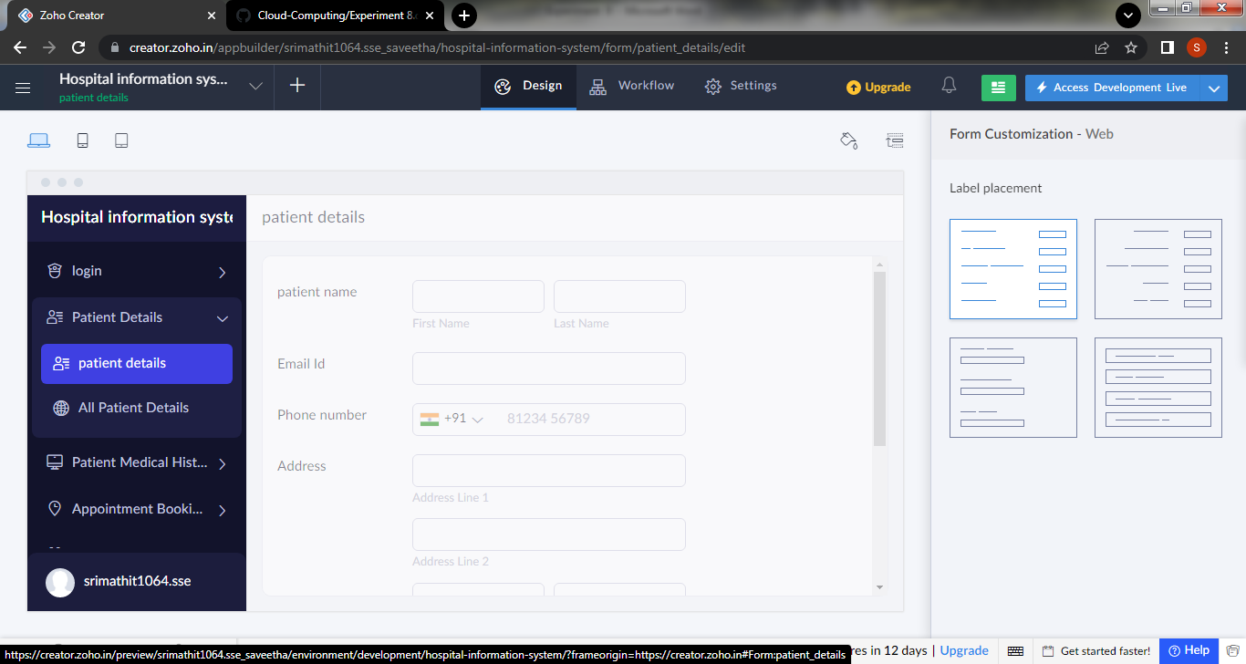

Step 8: Create a form for to get the patient’s medical history.

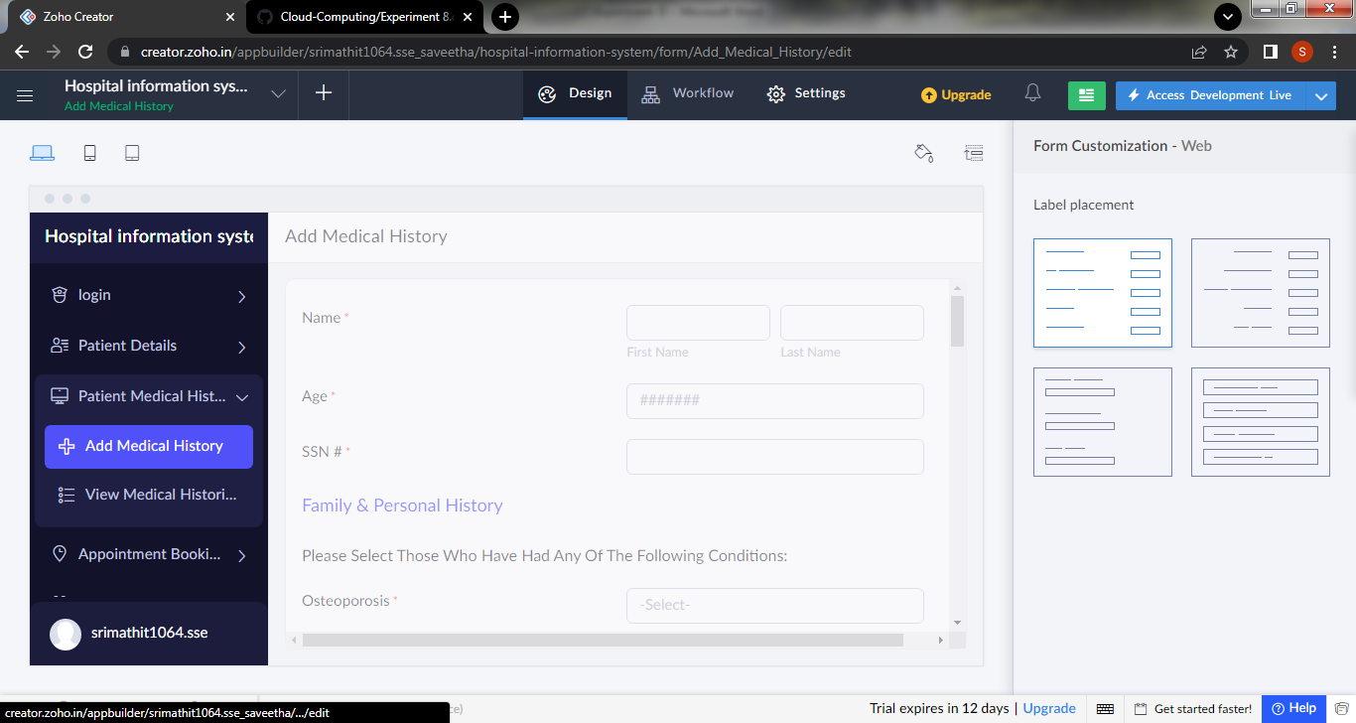

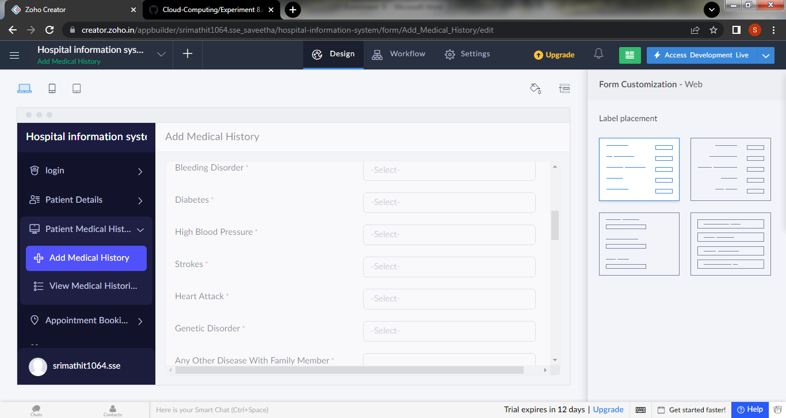

Step 9:create a new form for the appointment booking

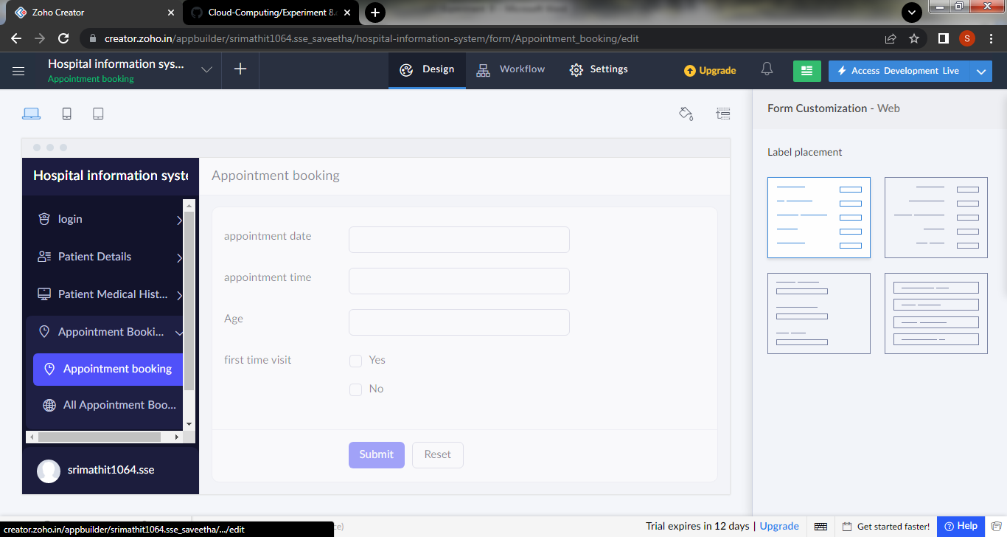

Step 10: create a form for the confirmation of the appointment booking

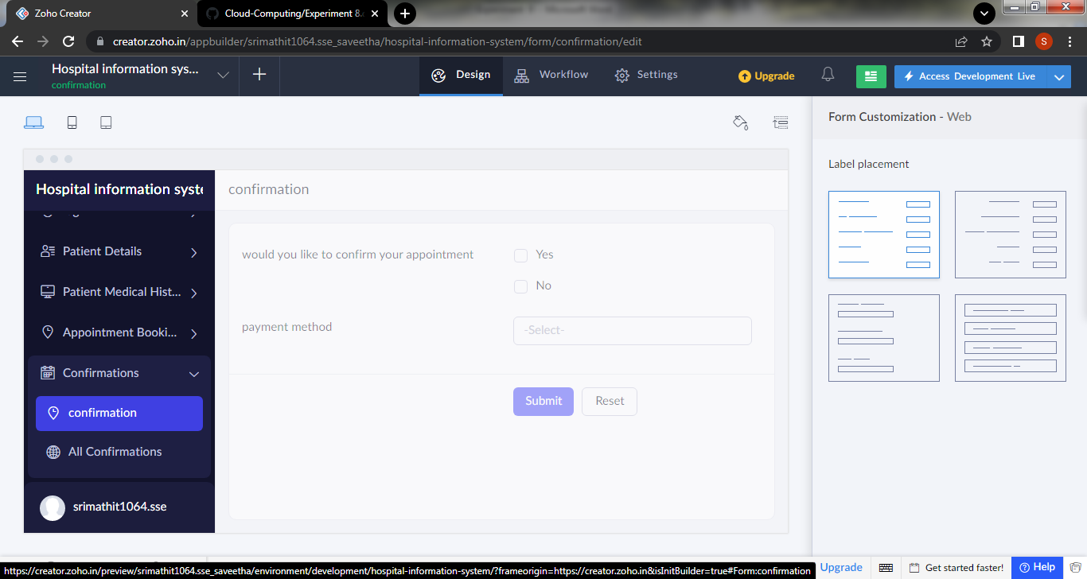

Step 11: click the access development to view the live output

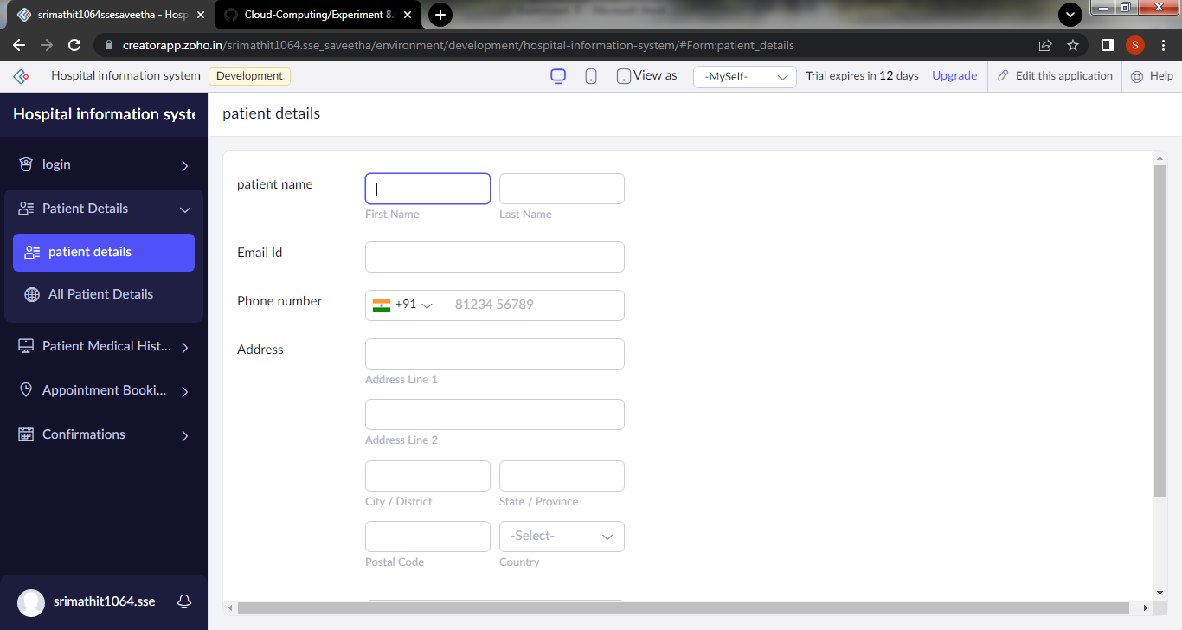

Step 12: click the report icon to view the data that are added

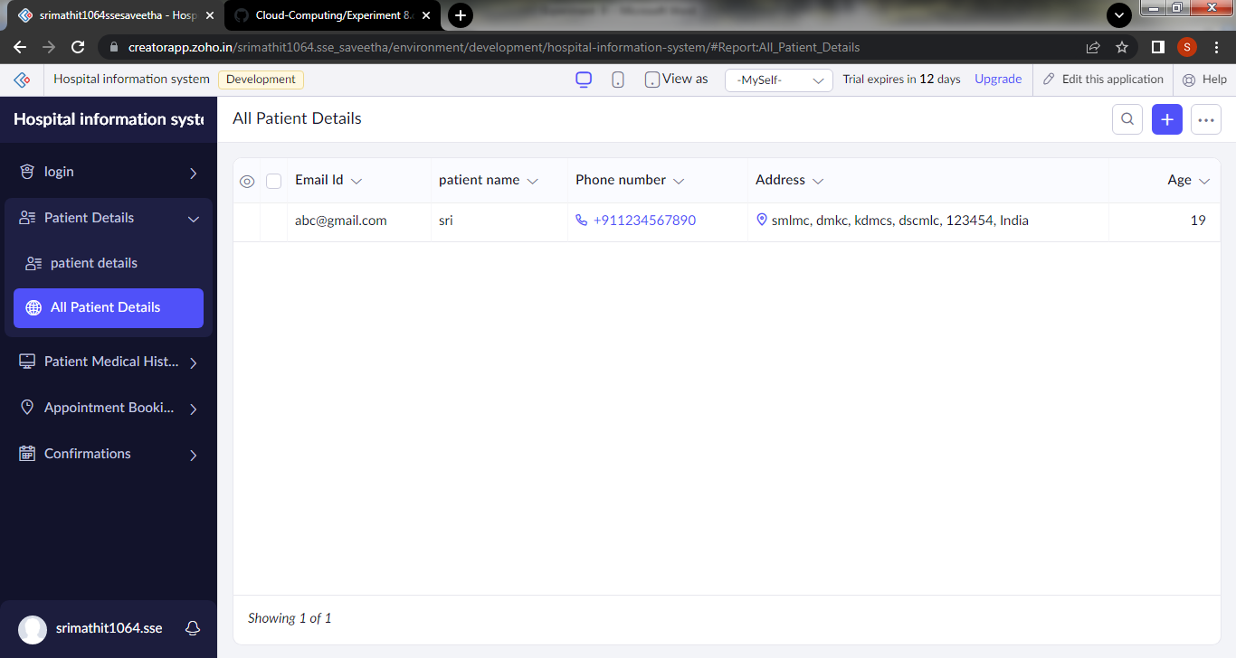

Step 11:click the mobile icon to view the output in mobile form

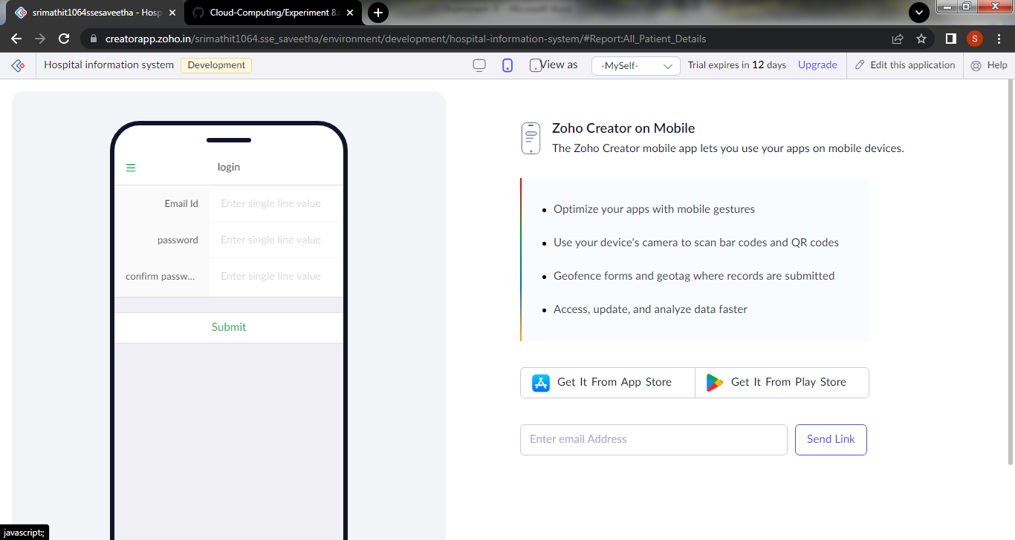

Step 12: click the tablet icon to view the output in tablet form

